8.0 Screen Shots & User Manual

HOME PAGE



DISPLAY ITEM PAGE

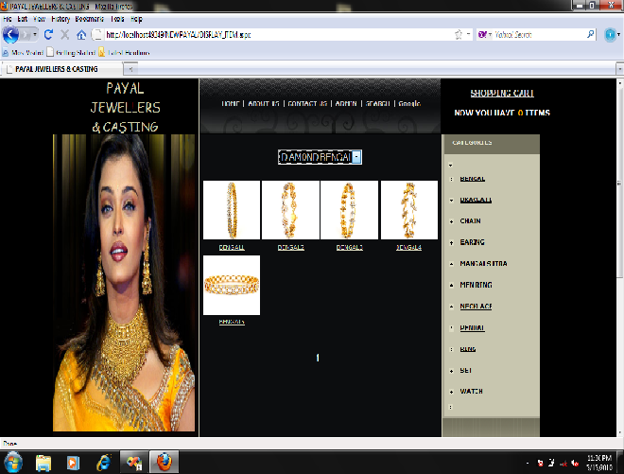

PRODUCT DETAIL PAGE

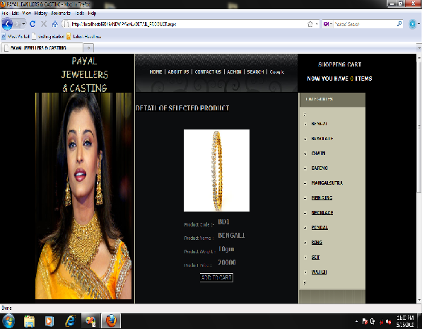

ADD TO CART PAGE

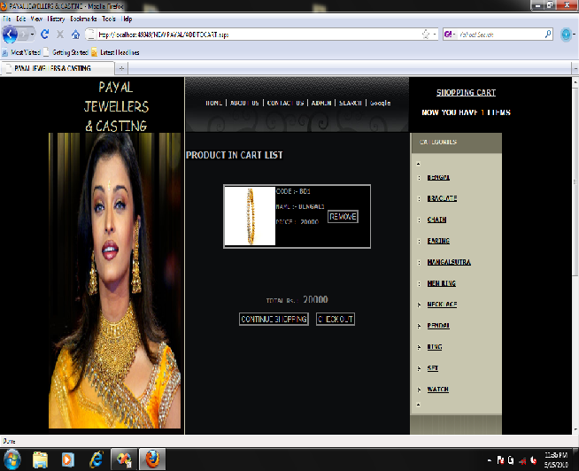

USER LOGIN PAGE

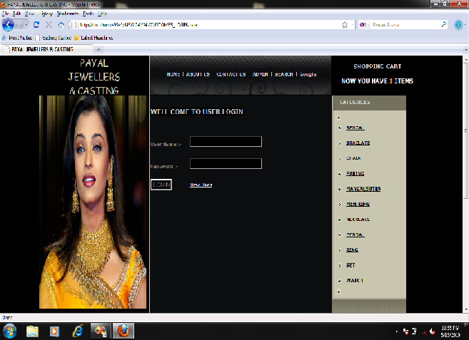

CUSTOMER DETAIL PAGE

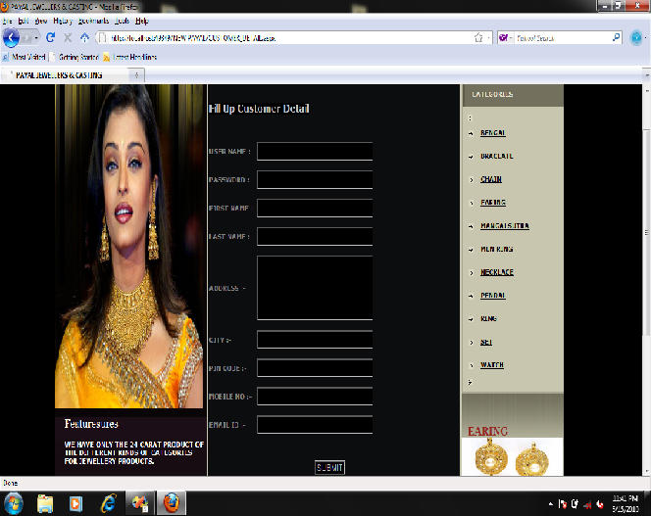

PURCHASED DETAIL PAGE

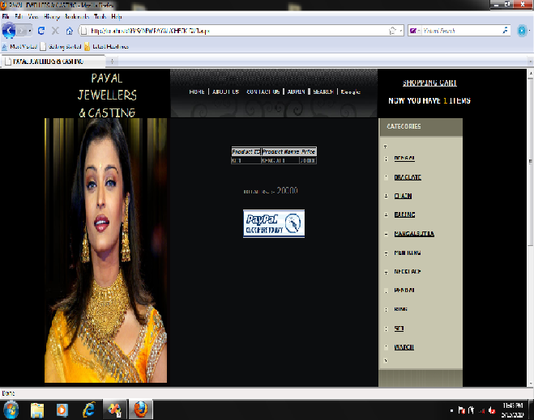

SEARCH ITEM PAGE

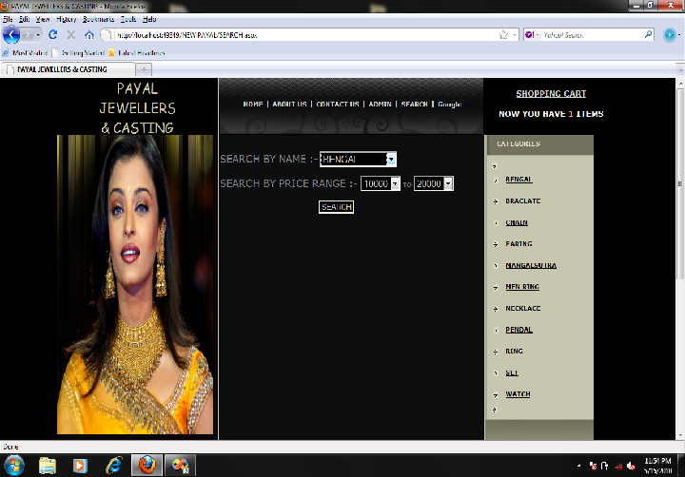

- ADMIN SIDE PAGES

ADMIN LOGIN PAGE

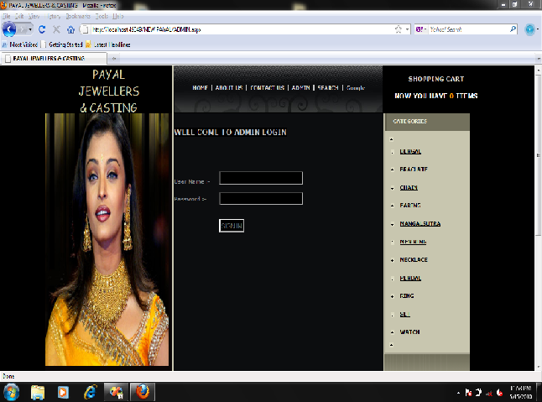

ADMIN TASK PAGE

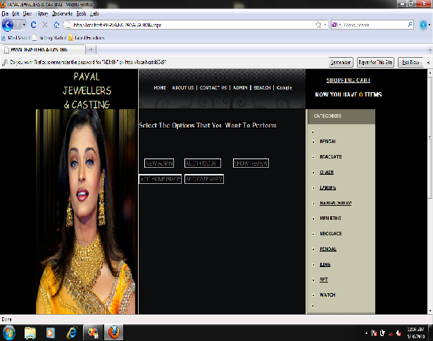

NEW ADMIN PAGE

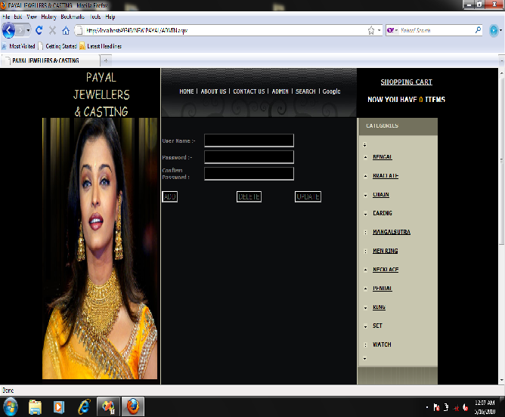

ADD PRODUCT PAGE

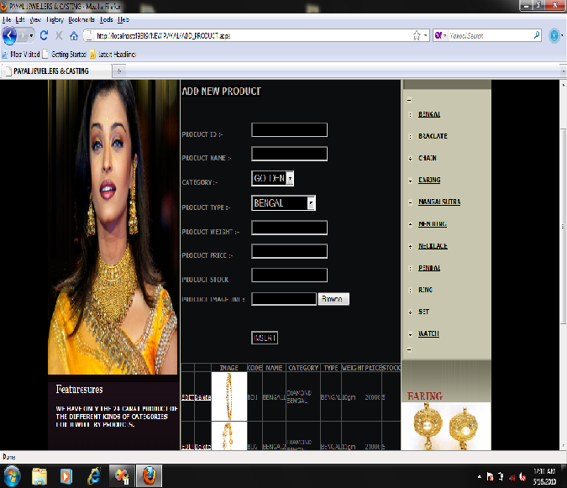

ADD CATAGORY PAGE

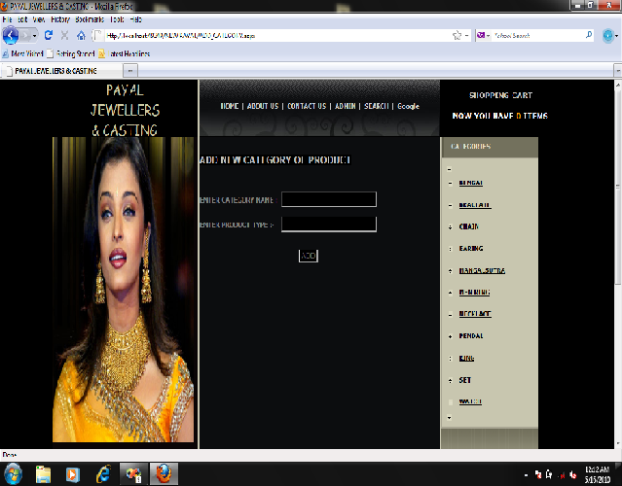

ADD HOME IMAGE PAGE

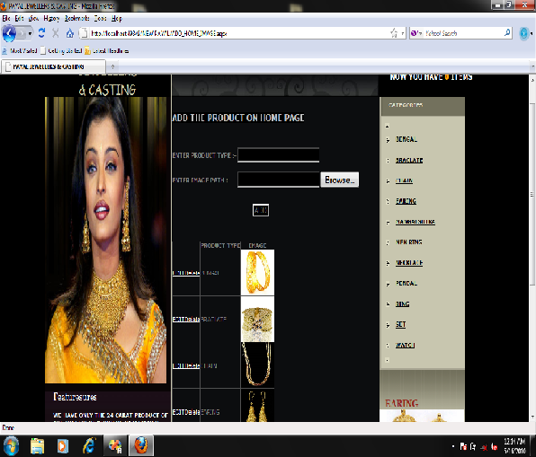

CUSTOMER REVIEW PAGE

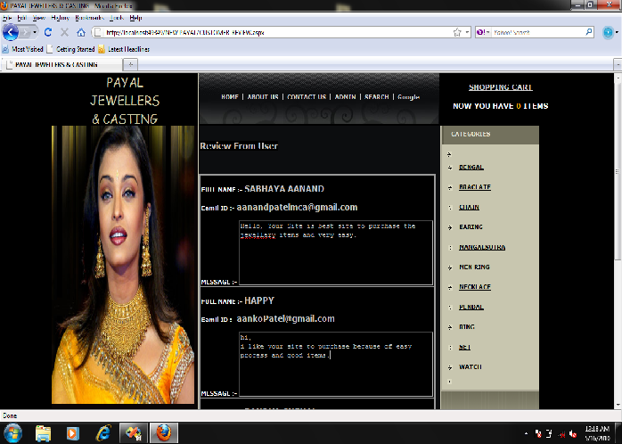

CONTACT US

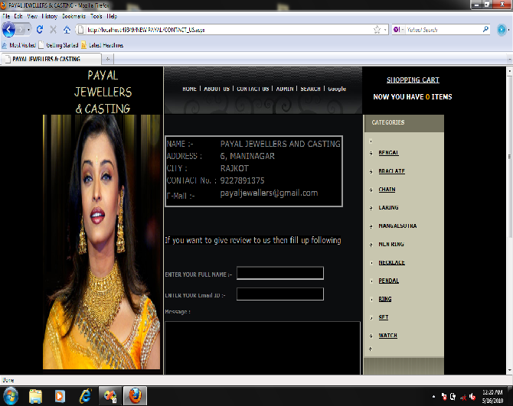

ABOUT US PAGE

